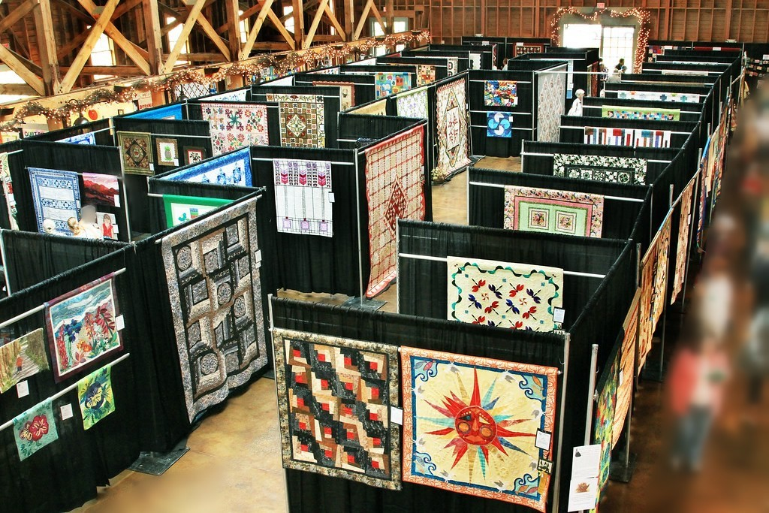

Sandhills Quilters Guild Presents

Quilting in the Pines IX

September 23rd and 24th 2022 10 am-5 pm. Admission $8

Vendors Boutique Raffle Baskets Food Trucks

The Historic Fair Barn, 200 Beulah Hill Rd. S, Pinehurst, N.C.

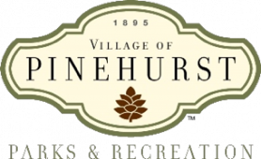 www.sandhillsquilters.org

